Ancient India Study Guide:
Know the definitions for each of the following words:
- subcontinent - ____________________________________________________________
- monsoon - _______________________________________________________________
- Sanskrit - ________________________________________________________________
- Vedas- __________________________________________________________________
- raja - ____________________________________________________________________
- caste - ___________________________________________________________________
- guru - ___________________________________________________________________
- Hinduism - _______________________________________________________________
- Brahman - _______________________________________________________________
- reincarnation- ____________________________________________________________
- dharma- _________________________________________________________________
- karma- __________________________________________________________________
- Buddhism- _______________________________________________________________
- nirvana- _________________________________________________________________
- stupa- ___________________________________________________________________
- pilgrim- __________________________________________________________________
- Bhagavad Gita- ____________________________________________________________

Identify 2 ways that physical geography and climate influenced the rise (and fall) of early civilizations in India. (Hint: WHERE you live influences HOW you live)
- ____________________________________________________________________________________________________________________________________________________

- ____________________________________________________________________________________________________________________________________________________

Label a map of India with these the geographical features:
India
Asia
Ganges River
Indus River
Deccan Plateau
Arabian Sea
Indian Ocean
Bay of Bengal
Himalayan Mountains
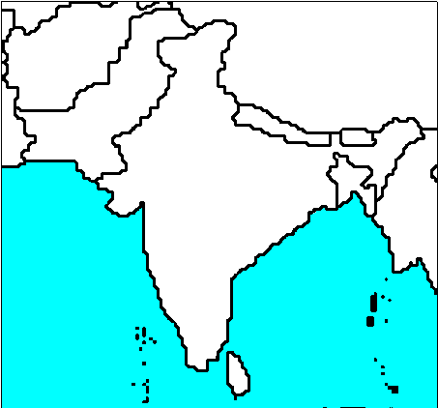

Match the holy books or moral codes of conduct with the religions of Christianity, Hinduism, and Buddhism.

The Eightfold Path | The 10 Commandments | Dharma & Karma
The Vedas | Sutras | Bible

Hinduism ______________________________ and ______________________________
Buddhism ______________________________ and ______________________________ Christianity ______________________________ and ______________________________

List TWO of Ancient India’s important contributions to humankind in each of the areas of:

Medicine ___________________________________________________________________
Math ______________________________________________________________________
Science ____________________________________________________________________
Culture __________________________________________________________________

Draw and label the caste system pyramid.

Common people | warriors, rulers
Brahmins | Sudras
Vaisyas | Untouchables
priests | Kshatriyas
Unskilled laborers, servants | garbage collectors

You will need to review the following ideas and be ready to construct a written response.

- Prepare to discuss the Four Noble Truths as they relate to the Buddhists belief about man’s suffering.

- Prepare to discuss the decline of the Mauryan Empire.

- Prepare to discuss the caste system of India and how it affected people’s lives.

- Prepare to discuss the development of Hinduism OR Buddhism, including its origins and key teachings.

